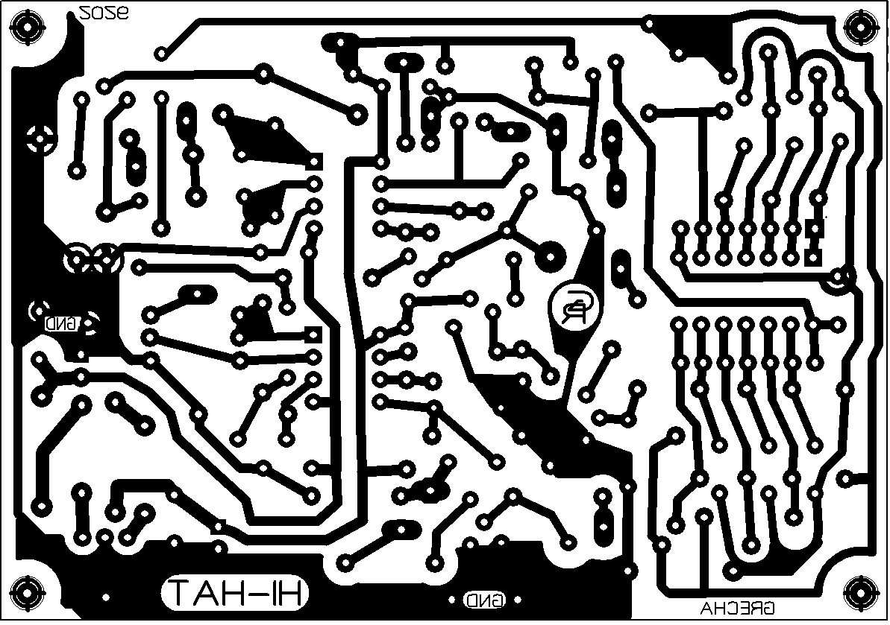

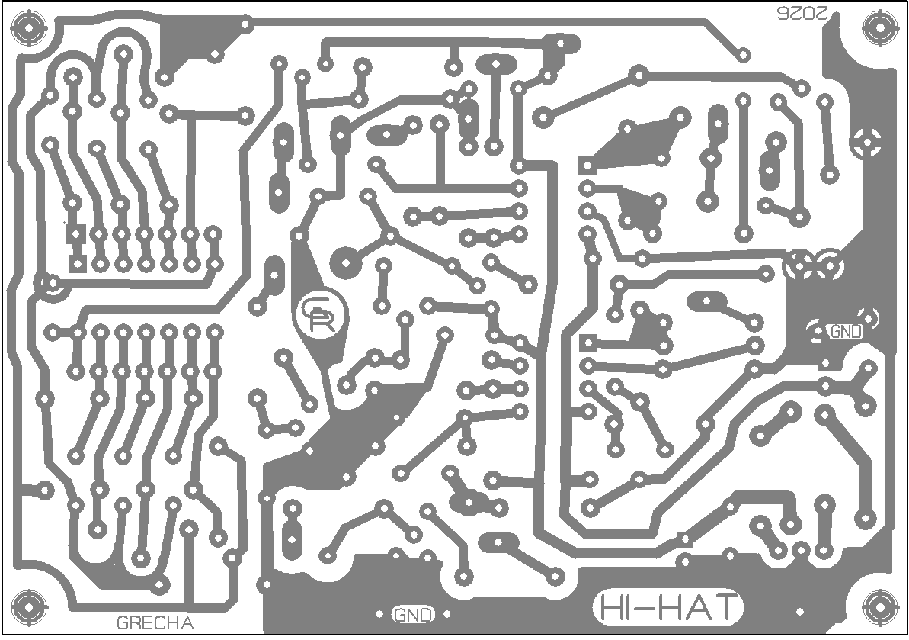
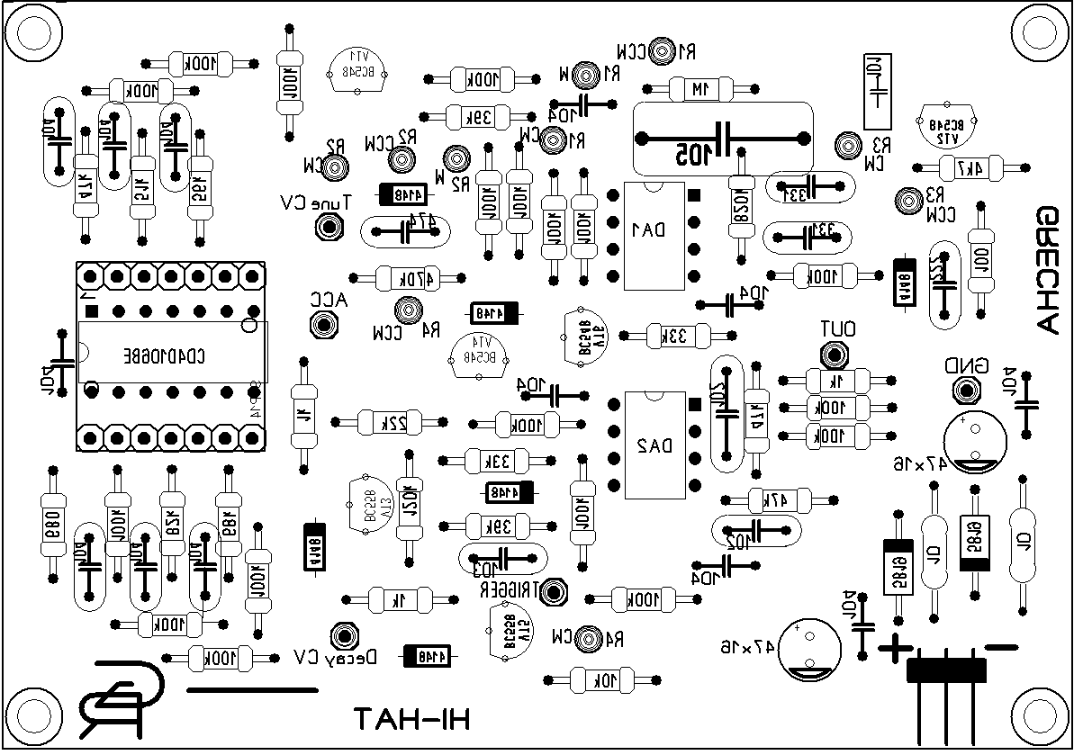
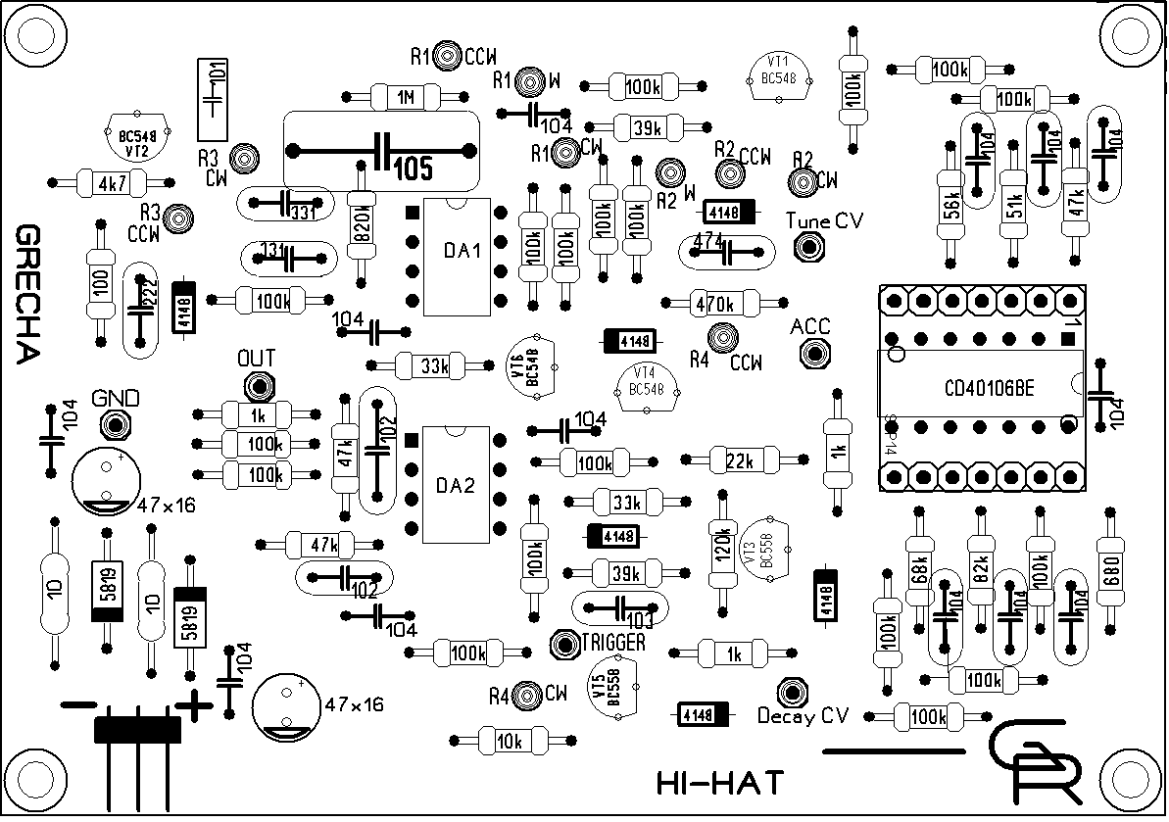
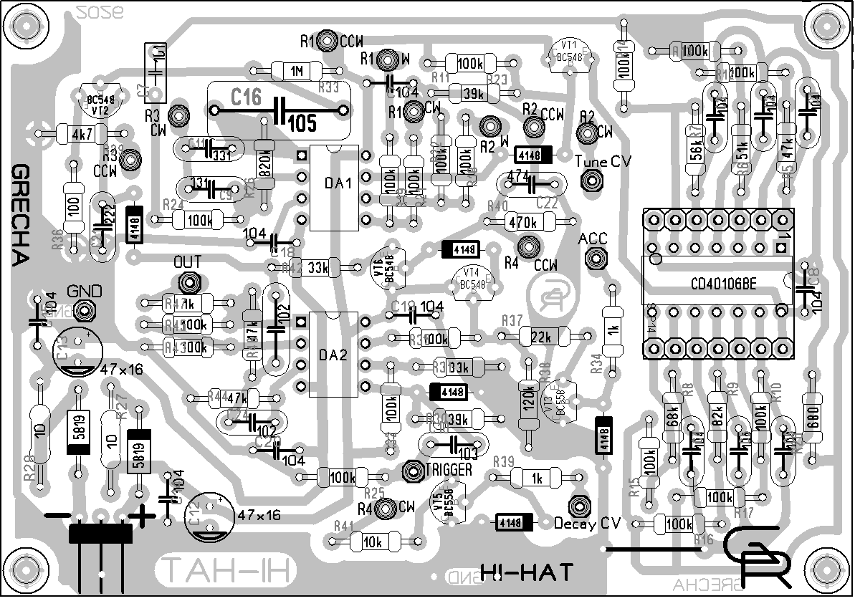
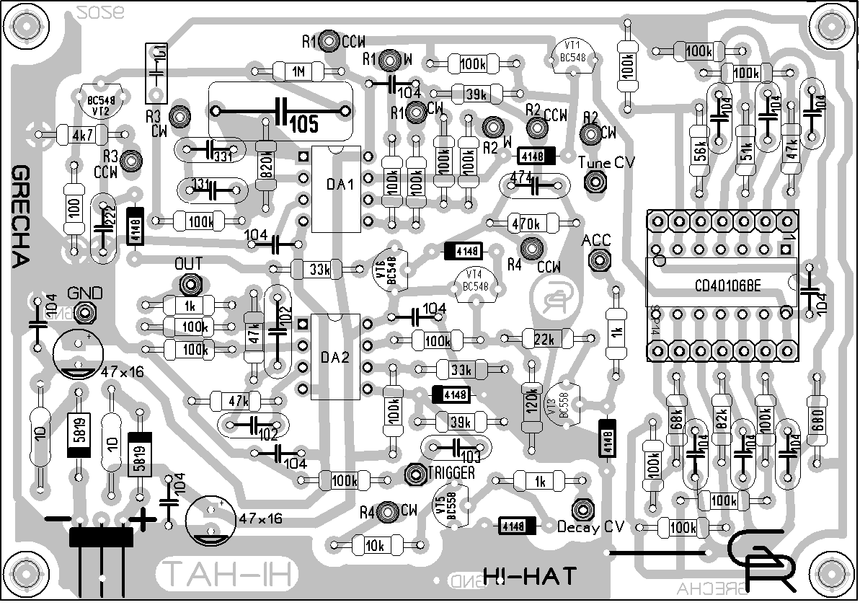

1M x1
820k x1
470k x1
120k x1
100k x18
82k x1
68k x1
56k x1
51k x1
47k x3
39k x2
33k x2
22k x1
10k x1
4k7 x1
1k x3
680? x1
100? x1
10 x2

47µF (electrolytic) x2
1µF (foil) x1 (105) 150mm
470n (ceramic) x1 (474) 6mm
100nF (ceramic) x13 (104) - 2 m10 в БП
- 6 104J 100V
- 5 ж капли к OD
10nF (ceramic) x1 (103) 6mm
2n2 (ceramic) x1 (222) 6mm
1n (ceramic) x2 (102) 6mm 1n
330pF (ceramic) x2 (331) 2а разных но есть 220
100pF (ceramic) x1 (101) 5mm

1N4148 (signal) x6
1N5819 (schottky) x2

BC558 (PNP) x2
BC548/547 (NPN) x4

250k (B254) x1
100k (B104) x1
10k (B103) x2

Switched mono (black) x5

TL072 (dual op amp) x2
40106 (hex schmitt trigger inverter) x1

